Builder Management

The Builder Management section is used to add and store the information of individual builders into our database.
A search bar for searching for a particular builder against the builder ID, name, builder URL and Status. Furthermore, when a particular builder is found we may edit the details thereof.

The output of the above search is a list of builders matching the specified parameters. Download CSV option enables to extract these results in .csv format.

Add New Builder :

As the name suggests this option is used to add new builder to the database.
All entries are filled in following tables:

- addresses.
- broker_contacts.
- company.
- table attribute
- seo_data.

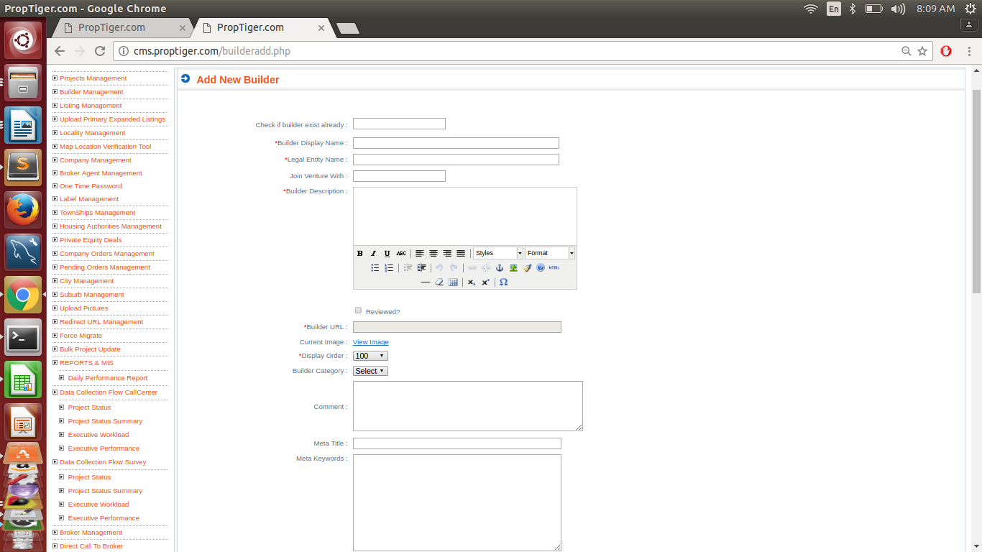

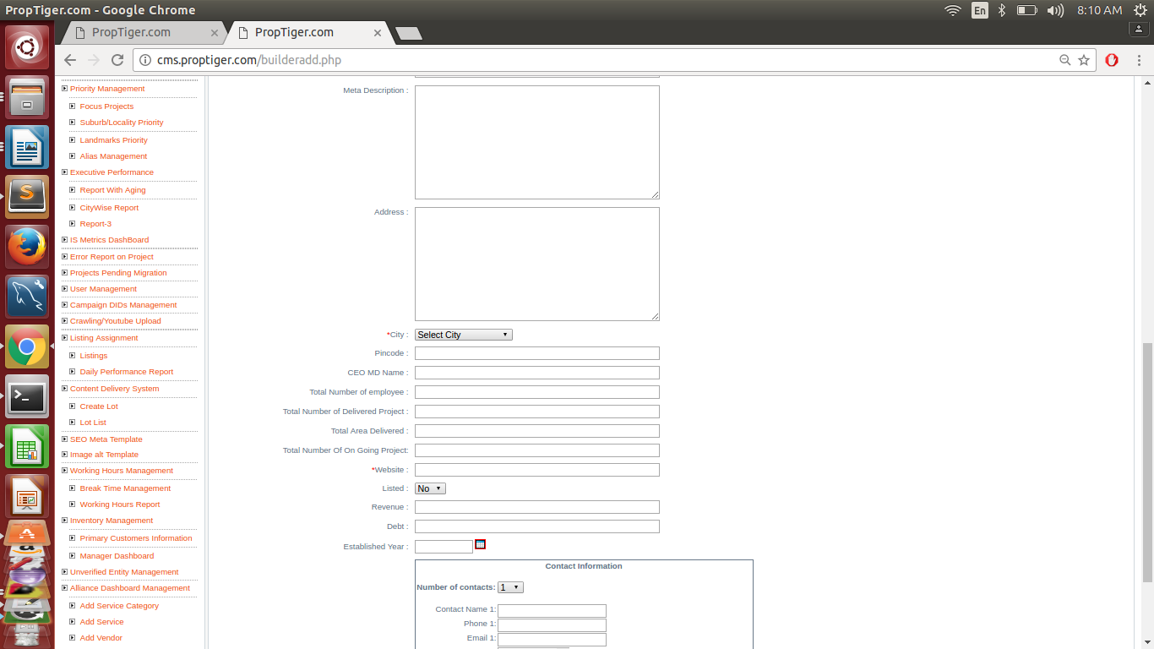

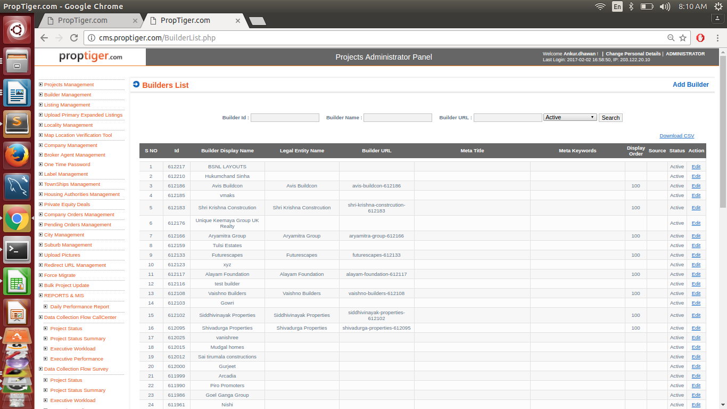

The various options alongwith the corresponding tables they are stored in, in this section are as follows :

1.check if builder exist already:- this field check builder name exist or not in resi_builder table.
2. *builder display name resi_builder (builder_name)
3. *legal entity name resi_builder( entity)
4.Join venture with tabale _attibutes.
5. *builder description resi_builder(description)
6.reviewed (check box)
7. *builder url resi_builder(url)
8.current image pixie.Image table
9. *display order resi_builder
10. comment
11. meta title seo_data
12. meta keyword seo_data
13. Meta description seo_data
14. Address resi_builder
15. *City resi_builder (city_id) -> Adressess
16. pincode resi_builder
17.CEO MD name resi_builder
18. Total number of employee resi_builder(total_on_of_empl)
19Total number of delivered project resi_builder(total_no_of_delivered_project)
20. total area delivered resi_builder (area_delivered)
21.total number of on going project resi_builder(ongoing_projects)
22. *Website resi_builder(website)
23.listed resi_builder(listed)
24.revenue resi_builder(revenue)
25.Debt resi_builder(bebt)
26.Established year resi_builder(Established_date)

contact information box

1.number of contact broker_contacts
2.Conatct Name 1. broker_contacts
3.Phone 1. broker_contacts
4.Email 1. broker_contacts
5 Project 1: broker_contacts
6. Board Contact 1: broker_contacts

Note: All * mark are mandatory field

Queries:

Query for checking mandatory filed is null.

Select builder_name,entity,DESCRIPTION,url,DISPLAY_ORDER,city_id,website,status from resi_builder
where ( ( builder_name is null or builder_name=' ') or
( entity is null or entity=' ') or
(description is null or description=' ') or
(url is null or url=' ') or
(display_order is null or display_order=' ') or
(city_id is null or city_id=' ') or
(website is null or website=' ') and status='active');

Note 1 : Active builder are registered from cms/proptiger.
ActiveInMakaan are registered from makaan.com.
Note 2 : For proptiger/cms builder description are filled in resi_builder tables.
For makaan.com builder description are filled in entity description table.
Note 3 : builder url pattern:
entity-builder_id ( for example entity is vivek tiwari and builder_id is 501334
so url are vivek-tiwari-501334).

:

builder exist in resi_project but not in resi_builder:-

select DISTINCT rp.project_id,rp.builder_id
from resi_project rp
LEFT JOIN resi_builder rb ON rp.builder_id=rb.builder_id WHERE rb.builder_id is null;

This is happen only due to there type are other than builder in company table.

